Otolith Chemistry – On the forefront of fish ecology

Lab Pre-Read

In this week’s lab we will be exploring fish otoliths and the unique characteristics that make them a useful ecological tool.

What is an otolith?

Fish otoliths are often called “ear bones” but this is not actually true. They are indeed the hearing structures in fish, but they are NOT bones. Instead, they are an amorphous crystal of calcium carbonate. Amorphous means that they don’t show typical faceted crystal shape, they’re lumpy and not very crystal-y in appearance.

There are actually three sets of otoliths in bony fish (cartilaginous fish don’t have otoliths). These are the the sagittae (singular sagitta), lapilli (singular lapillus), and asterisci (singular asteriscus). In most fish, including salmon, the sagittal otoliths are the largest and most useful to ecologists. In species like catfish the lapilli are the largest.
Chinook Salmon Otolith (http://aforo.cmima.csic.es)
But, being a crystal they don’t have blood flow, which is important. It means that whatever material gets added to the crystal won’t get subtracted later. This is important. Bones are also calcium based (calcium phosphate), but they are full of growing cells and have lots of blood flow. This means that the calcium structures in bones get recycled through time pretty significantly. They don’t save chemical signatures over time.

Otoliths, on the other hand, do save information because of that long-lasting crystal structure. They reside in a fluid filled sac, just under the fish’s brain, with one end attached to a bunch of nerve endings. As the fish moves around these nerves sense how gravity moves the free-floating otolith, giving fish a sense of balance. Noises that get transmitted through the fish’s body are also picked up as vibrations in these otolith nerves.

How do otoliths grow?

But, despite being just a crystal floating in a fluid sac, otoliths grow right along with the fish. Every day the concentration of calcium and carbonate ions varies inside that fluid sac in relation to how fast the fish is growing, and the crystal grows a tiny new layer each day…thicker when the concentration in the surrounding fluid is higher, and thinner when the concentration is lower. In this way the otolith crystal grows like a tree, recording how fast the fish was growing for each day of its life.

How do they record fish behavior and growth?

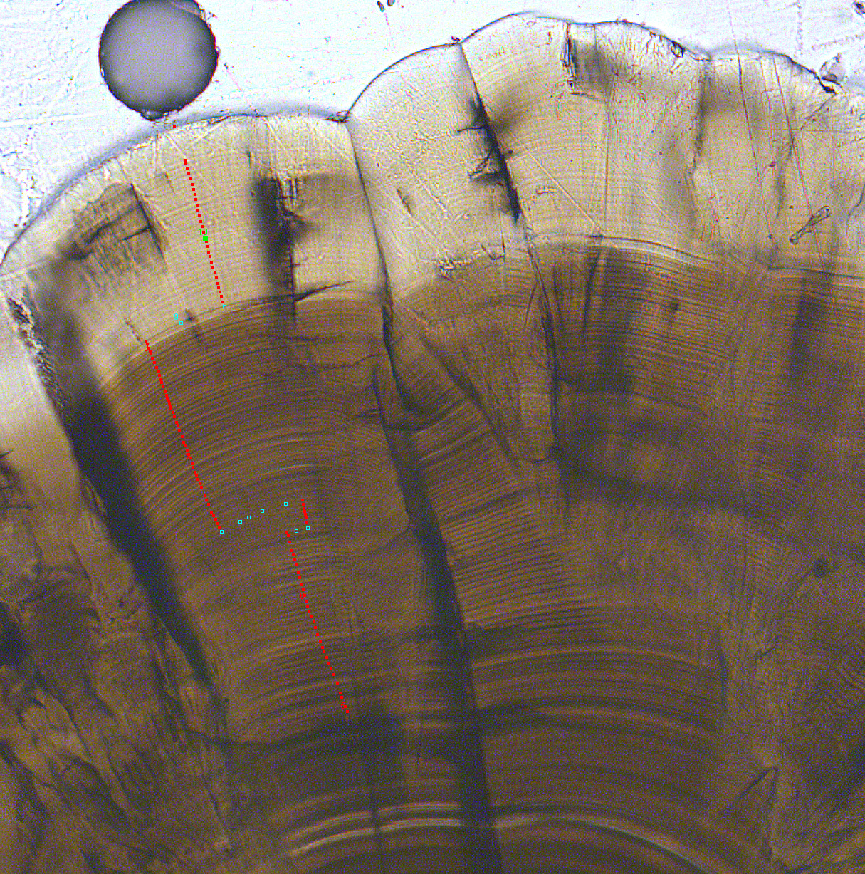
But calcium and carbonate ions aren’t the only things floating around in that fluid. The chemistry of the fish’s environment is also present, in the form of isotopes and elements whose concentration is unique to the location the fish is living. Strontium isotopes, which otherwise are pretty ignorable for us ecologists, happen to vary a lot depending on what rocks make up each watershed. Often watersheds across a fish’s range have unique signatures of strontium isotopes, which is super useful for fish ecologists.

Remember from your last chemistry class what an isotope is. It’s an atom with the number of protons and electrons for the element, but a different number of neutrons. This causes the isotope to have a larger or small atomic weight. In the case of fish we care most about the isotopes ⁸⁷Sr and ⁸⁶Sr. Strontium 87 (⁸⁷Sr) varies depending on how old the rocks are as well as what type of rock it is, while ⁸⁶Sr doesn’t vary. Using the ratio ⁸⁷Sr/⁸⁶Sr gives us a shorthand to understand the variation of strontium isotopes.
Growth rings and counting points (red) on a juvenile Chinook salmon otolith (courtesy Jens Hegg, Kennedy LIFE Lab)

Strontium is in Group 2 on the periodic table, just below calcium…which makes all the difference! Because the strontium atom is so similar to calcium it can come into the fish’s body through the calcium channels in the cell. But, unlike calcium, the cell doesn’t have a use for strontium, and so no cellular processes change the ratio of ⁸⁷Sr to ⁸⁶Sr. That means that the ⁸⁷Sr/⁸⁶Sr ratio in the fish (and in that fluid filled sac around the otolith) looks the same as the water the fish is swimming in.

This is where being similar to calcium is important for one more big reason. As the otolith adds calcium carbonate strontium sometimes replaces calcium in the crystal because the atoms are so similar in shape and size, and they both have a +2 charge. So, that ⁸⁷Sr/⁸⁶Sr ratio of the water the fish is swimming in gets recorded in the rings of the otolith, creating a record of the strontium signatures of each river the fish has swam through.

Why are otoliths useful for fish ecologists?

As an ecologist this is a gold mine! That means otoliths record growth (which we know is a big deal for ecological research) AND they record where a fish has been in its life. That is a huge amount of information!

Otoliths are special because there are very few tracking technologies that are capable of recording this level of detail about the life of a fish. PIT tags, acoustic tags, electrofishing, all can provide important data. But, they are usually limited to fish above a certain size, and most of them only work for short amounts of time, across short distances, or only at places were a detector is present. Otoliths record this information from birth to death, every single day. That’s a pretty impressive trove of information.

Otoliths also record much more information than just ⁸⁷Sr/⁸⁶Sr. Ecologists use otoliths to recover signatures of other isotopes and elements that can also be used to understand where fish were. Even more interesting people have used carbon isotopes in otoliths to reconstruct the metabolism of fish, and people are even starting to use calcium isotopes to uncover the temperature of the water fish were swimming in. There are SO many cool uses for otoliths and more are being added every year.

But, what are the downsides?

Otoliths are not a panacea, even if they work incredibly well when everything is just right. In order to work well for retracing location the habitat a fish moves through has to have variation in water ⁸⁷Sr/⁸⁶Sr that is at a scale that is useful (scale…uh, oh…here comes Fausch again!). If there isn’t enough ⁸⁷Sr/⁸⁶Sr variation between habitats the method will fail. If there’s too much variation fish might not spend enough time in any one spot to pick up a useful signature. And, if fish aren’t growing then their otolith rings might be too faint to count, meaning that that period of their life is lost in the otolith record. So, otoliths are a great tool, but they only work in the right circumstances. Luckily, the right circumstances tend to happen pretty frequently.

How do we analyze otoliths?

Getting this information out of an otolith that is anywhere from the size of a sesame seed (or smaller) to the size of a half a pecan is not necessarily simple.

Usually, the otolith is glued to a glass microscope slide and either cut or polished to reveal the rings. In young fish the daily rings can be counted and measured under a microscope to create a record of the growth of the fish.

Reconstructing growth requires comparing the width of otolith growth bands to the length of the fish, in order to create a mathematical relationship of otolith width (usually in µm per day – one ring equals one day) to fish length (in mm). Once we have that relationship, we can calculate the speed of growth (mm/day) for any given ring.

Uncovering the 87Sr ratio requires some special equipment. To do this most scientists use a laser ablation multi-collector inductively coupled plasma mass spectrometer. Say that five times fast! Most people shorten this to LA-MC-ICPMS or just ICPMS.
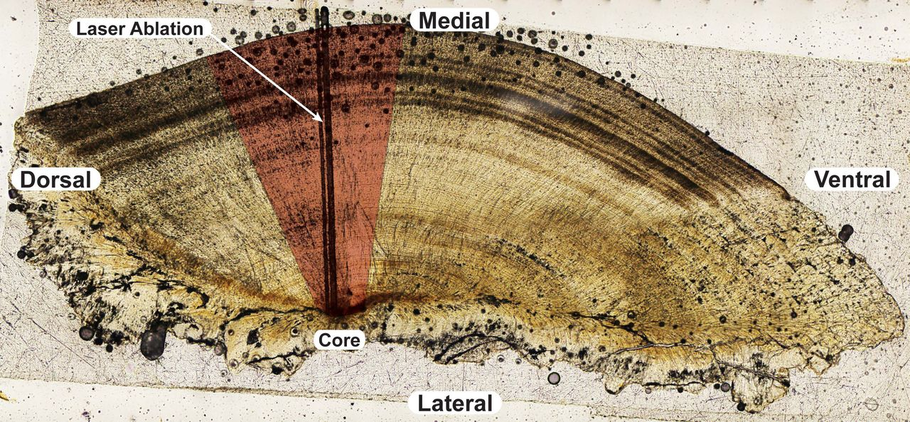

The gist of the ICPMS technique is to use the mass of the atoms to separate each isotope using centripetal force (this is the mass part of mass spectrometry, spectrometry is the separation of those isotopes). The first step is to sample the otolith material. We do that with a tiny laser that blows tiny bits (I use a 35µm laser beam, pretty tiny) of calcium carbonate off the surface of the otolith. These are turned into a plasma (the Plasma part of the name) a hot ionized gas. Then all of the sample is accelerated around a curve using a magnet. The heavier isotopes curve less than the lighter ones because of their extra weight (imagine the turning radius of a Honda Civic versus the turning radius of a Mack truck if they were each going 100 miles an hour). These ionized strontium isotopes then hit detectors that allow us to count the amount of each isotope because the ion’s charge creates an electrical current that we can count. It’s all pretty genius even if the name is a tongue twister.
Lapilus otolith of Amazonian migratory catfish showing laser ablation tracks (Hegg et al., PLOS One, 2015)

We usually use that laser to analyze the changes in ⁸⁷Sr/⁸⁶Sr from the birth of the fish (at the otolith core) to when it died (at the edge) which gives us a reconstruction of the strontium signatures the fish lived in during it’s life. We usually call this a “life history transect”.

Comparing this life history transect with the ⁸⁷Sr/⁸⁶Sr values of the water in a fish’s habitat lets us determine where it’s been. There is no fancy calculation to do this. Literally, the ⁸⁷Sr/⁸⁶Sr signature of the fish should match the ⁸⁷Sr/⁸⁶Sr of the water (or somewhere close, there’s error in every measurement).

After we have that information we can start asking questions about how long a fish stayed in each location, how fast it grew while it was there, when it left, and how the movements it made affected it’s life later on. All of these things, once you look at them for a large sample of fish, can be critical to understanding the ecology of a population.

Where has otolith chemistry been used successfully?

Ecologists have used the chemistry of otoliths to track the migration of some pretty wild species. The giant taimen trout in China, bluefin tuna, Amazonian giant catfish, and salmon migrations have all been studied using this method. The same for more common species like smallmouth bass and American shad. Dr. Kennedy and his graduate student Ellen Hamman, here at Univeristy of Idaho, used this method to show that Chinook salmon in the Frank Church wilderness often return to within just a few kilometers of where they were born.

Otolith chemistry is a really cool, and fast growing, field in ecology. The uses for this type of work are expanding every year and the amazing things we’ve learned about fish as a result are incredible.

