Otolith Chemistry – On the forefront of fish ecology

Lab Procedure

In this lab we’ll be analyzing ⁸⁷Sr/⁸⁶Sr life history transects for Fall Chinook salmon, comparing otolith size to fish length, and making some observations about life history and growth.

We will be analyzing ⁸⁷Sr/⁸⁶Sr data from adult Snake River Fall Chinook otolith samples. In this population juveniles usually hatch, grow quickly, and out-migrate to the ocean quite early, usually before late summer. But, in recent years evidence indicates that many are outmigrating later, even spending the winter in the river before outmigrating the next spring (and extra 4-6 months).

Does the ⁸⁷Sr/⁸⁶Sr data back up this claim, that some fish are changing their life-history and outmigrating later? Lets find out!

The entire lab will be completed in the statistical program R using the RStudio interface.

Lab Setup

- Download the most recent version of R statistical software for your computer from the link below and install it. (If you’re using a UofI lab computer you’ll already have the most recent versions)
  - https://www.r-project.org
  - (the current version is apparently 4.0.3 “Bunny-Wunnies Freakout”…I can’t make this stuff up, lol!!)
- Download and install the latest free version of RStudio Desktop for your computer platform. (again, if your using a student lab computer you can skip this, it’s already installed)
  - https://rstudio.com/products/rstudio/download/ (no funny name here…dang.)
- Go to the following link and download the folder “IsoFishR – master” to a location on your computer that you can find again. These are all the files you’ll need to complete the lab, and is also where all of the files you create for this lab will go.
  - https://www.dropbox.com/sh/i0j9axqvx0xj7pl/AADWK3LzV6HQuazBneQp6uWFa?dl=0

(next page)

Life History Transect Data Analysis

The first step in recovering fish otolith signatures is to analyze the data received from the ICPMS. There are two steps to this. The first is called Data Reduction, the second is Data Analysis.

Data reduction takes the raw count data of the isotopes, corrects it to a standard, removes noise from the signal, and makes the ratio of ⁸⁷Sr to ⁸⁶Sr. In this exercise the data reduction step has already been done for you.
Our job is to complete the Data Analysis step. This requires trimming the useful data, then determining and quantifying the distinct locations that fish inhabited, and quantifying the length of each segment.

We’ll be doing this with the R package IsoFishR (Willmes et al., 2018) which is available from Github. I’ve already downloaded it and started a project for us which is in the file you just downloaded.

To start the data analysis:

- Open RStudio into a new session
- In the top left go to “File > Open File…” and navigate to the “IsoFishR – master” folder you downloaded.
  - Inside that folder select the “IsoFishR.R” script file and open it
- This will open an R script in the upper left window of RStudio.
- In the commands in this upper left window find the small black arrow to the right of the “Run” command and click it to bring up the context menu.
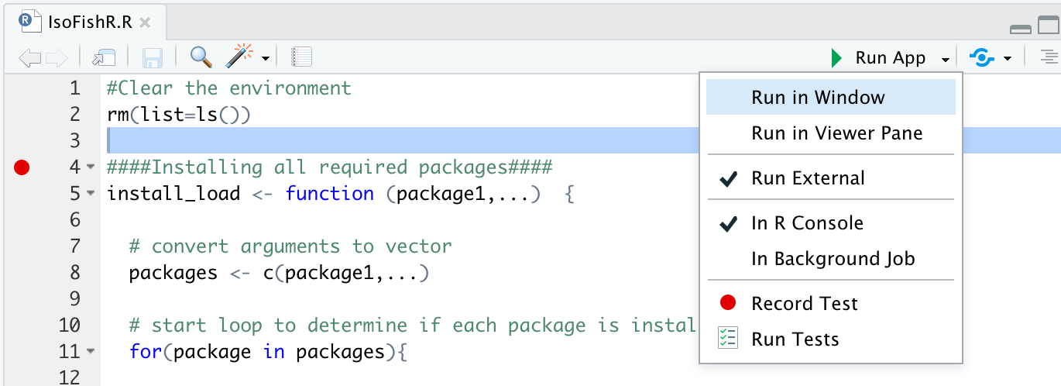
- Make sure that the “Run External” option is selected. It should look exactly like the picture.
- Now click “Run”

The first time you click the run command the script will check for all of the packages that IsoFishR needs and download them. You need to be connected to the internet and it might take awhile. You should see things happening in the console window in the lower left. It may ask you if you’d like to “download packages in source that need to be compiled”. Say “no” to this and it will download the versions of those packages that will automatically install.

IsoFishR is a Shiny App that runs in R but opens a browser window that acts as the interface. When IsoFishR finishes downloading all the required packages it should open up a browser window automatically that looks like the one below. If it doesn’t hit the “Run” button again.

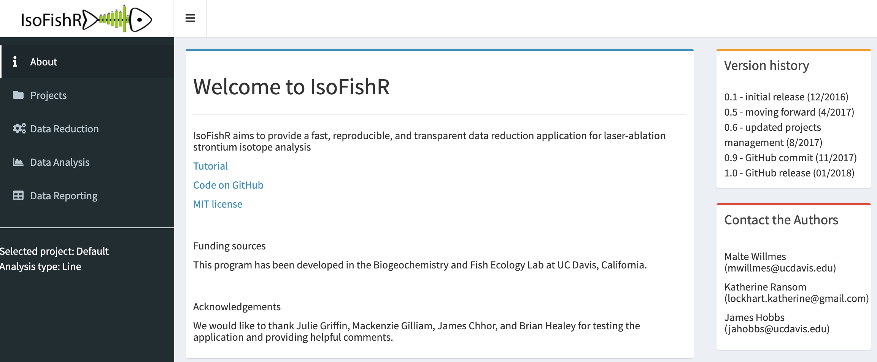

- Click on the “Projects” option on the right to select the project we are going to be working on.
  - Under “Select Project” use the pulldown menu to select “Otolith Lab”
  - DO NOT hit “Save new project” selecting it is all you need to do.
  - Check to make sure the settings look the same as the picture below.

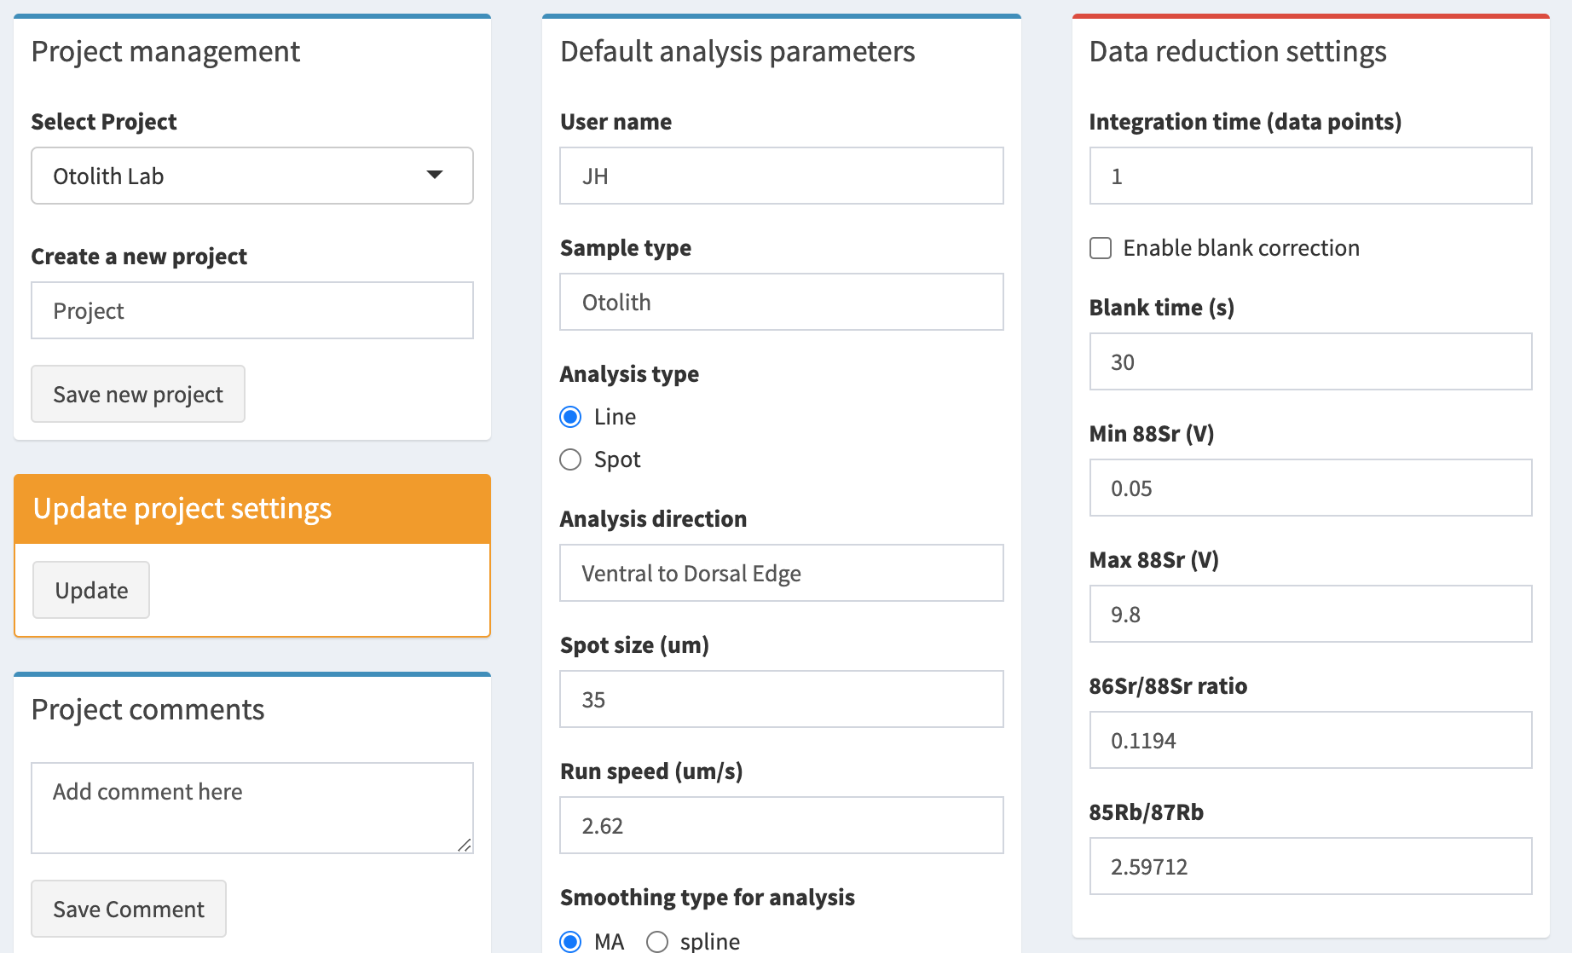

- Data Reduction has already been completed for our data, so click on “Data Analysis” in the left hand menu to bring up a page that looks like this.

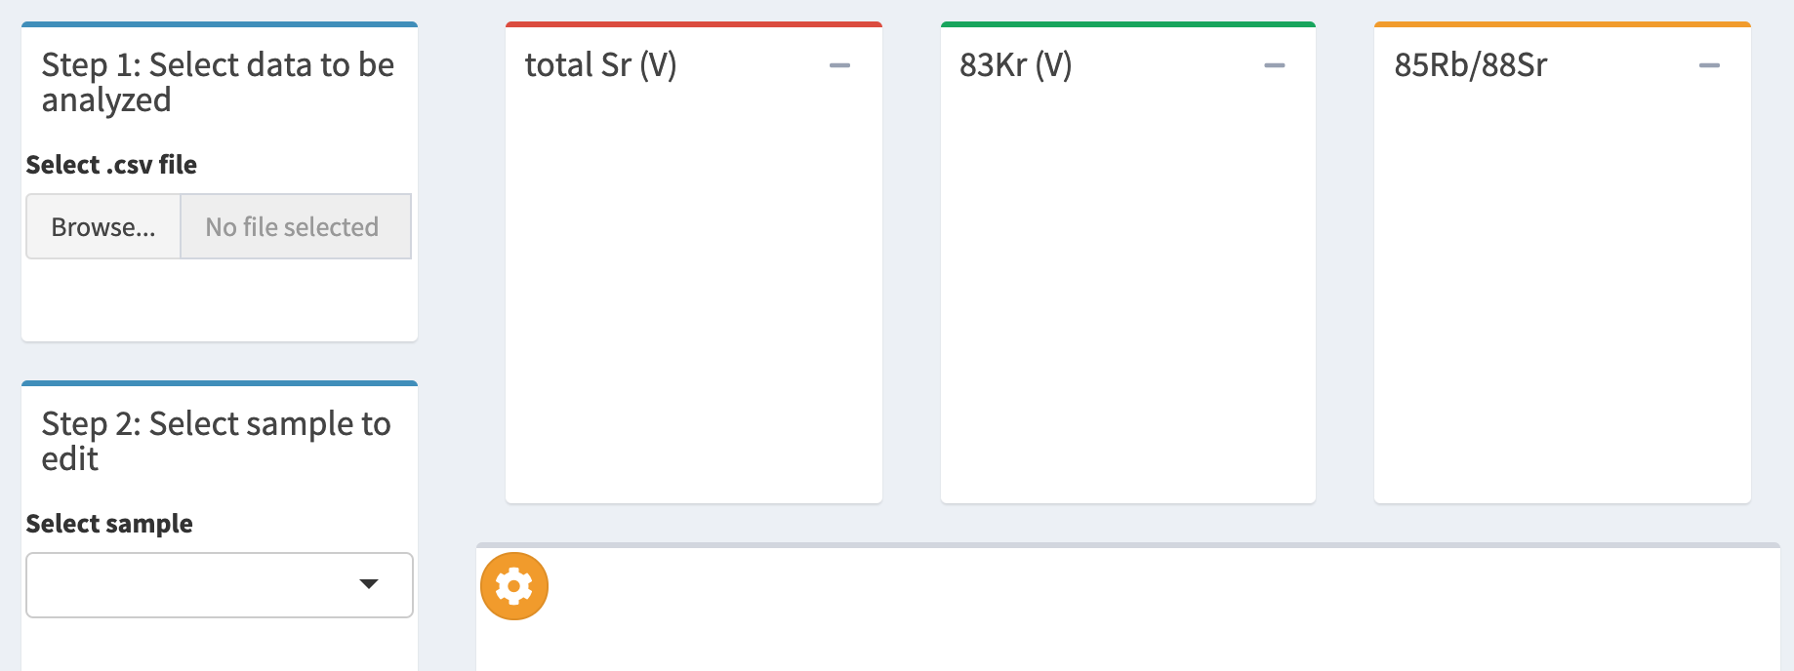

  - Click the “Browse” button under “Select .csv file”
    - This should open the “Data” folder inside the “IsoFishR – master” file. If it doesn’t the path to this folder is:
IsoFishR-master/Projects/Otolith Lab/Data/Otolith Lab_03_analyzed_data.csv
    - Click to open the Otolith Lab_03_reduced_data.csv file

- Once this file has uploaded, which should only take a moment, use the dropdown under “Select Sample” to select the first sample whose name should start with “2012-LFH-3082.exp”
  - This will populate the graphs with the sample data and the screen should look like this:

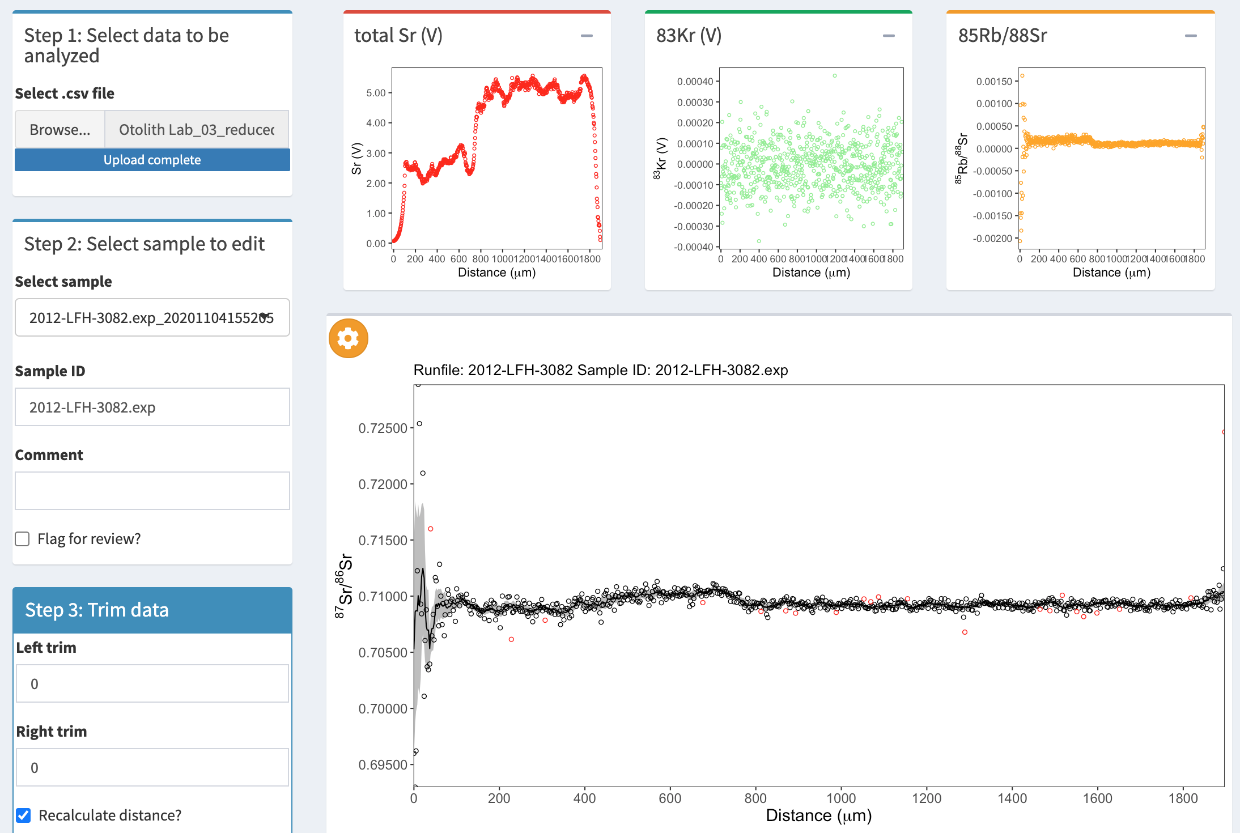
The first thing to notice is that the ⁸⁷Sr/⁸⁶Sr data on the left of the main plot looks kindof messy, with huge variance in the points. We need to trim the transect so that we only have real data and not noise.

We do this by looking at the red “Total Sr (V)” graph. This shows the total level of strontium of all isotopes being detected by the ICPMS detectors. The line moves around a lot, but when we see it start to decline in an exponential curve we know that the sample isn’t actually being laser ablated and this is just junk data.

- To trim the data for the sample use the “left trim” and “right trim” boxes.
  - BE CAREFUL at this step and follow these directions carefully or you could lose data and have to start over.
  - We want to trim the data right to the point at which the strontium starts to look like real data, as shown in the picture below by the blue arrows.

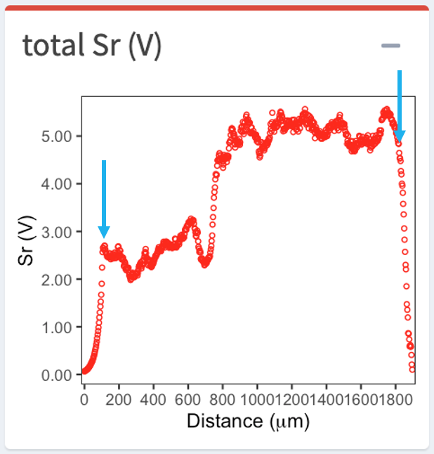

  - To do this, start with the “left trim box” and enter 20. This will remove 20µm of data.
    - Hit the “Save Edits to Profile” button in the lower right. This button updates the window, but also permanently deletes that 20µm of data.
    - Since this is permanent we want to go slow so we don’t go too far and remove data we want.
    - Repeat this step in 20µm pieces or less until the lefthand side is trimmed to the location of the left hand blue arrow in the above picture.
    - This should remove the messy looking area on the left of the larger graph as well, and the main ⁸⁷Sr/⁸⁶Sr plot should zoom in closer to the real data once the widely varying points are removed.
- Once you’ve trimmed the lefthand side repeat step 10 again, but use the “Right trim” box to remove the bad data on the right of the graph as well.
  - Your plots should not look like below. This is the final 87Sr/86Sr profile that shows the fish’s movements through it’s entire life.

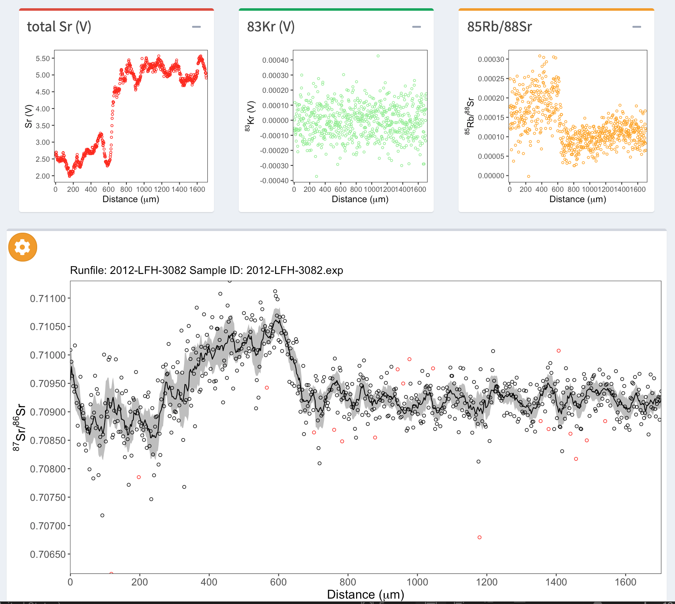

- Click the “Export analyzed data” button in the black square on the bottom right of IsoFishR to save your edits.
  - DO NOT click the “append data?” dialog box or you will duplicate your samples.
- You now have one sample trimmed and ready for analysis. Go back to step 9 and repeat this process for each of the other samples in the dataset.

Finding Developmental Stages and Downstream Movement

So, now that all of your data is trimmed, how do we get something useful out of these squiggly lines? We really need something to compare to.

You’ve probably already noticed that the righthand side of each graph is awfully flat. This is the ocean period of the salmon’s life. The ocean, worldwide, has the same ⁸⁷Sr/⁸⁶Sr signature, 0.70918. That is one way we can get our bearings with this data.

The other way we find our way around the data is to know the water ⁸⁷Sr/⁸⁶Sr of the rivers the fish may have swam through. In this case Snake River Fall Chinook spawn in either the Upper Snake River, Lower Snake River, or Clearwater River. So, we’d expect their signatures to reflect that. The table of ⁸⁷Sr/⁸⁶Sr values for these locations are below.

 |  | Range
River Reach | ⁸⁷Sr/⁸⁶Sr | Minimum | Maximum
Upper Snake | 0.7086 | 0.7084 | 0.7088
Lower Snake | 0.7096 | 0.7090 | 0.7099
Clearwater | 0.7130 | 0.7112 | 0.7159

In IsoFishR we can compare the ⁸⁷Sr/⁸⁶Sr transects to known values. To do this:

- On the main ⁸⁷Sr/⁸⁶Sr plot in the center of the screen click the gear icon in the top left corner.
  - First, click the radio button to select, “Mean Ocean”
    - This adds a blue line at 0.70918, the global ocean ⁸⁷Sr/⁸⁶Sr signature
  - Also click “Custom Line” and enter an ⁸⁷Sr/⁸⁶Sr value from one of the Snake River tributaries above into the box.
    - This places a yellow line on the plot at whatever value you add, allowing you to compare the known water values to the signatures in the fish.

Spend some time comparing the values of the Snake River tributaries to the 5 transects in your project. What rivers do you think they occupied prior to outmigrating to the ocean? Are there big differences?

But, as ecologists we need to be a bit more quantitative about this. How do we quantify how long a fish spent in one location? How many locations might they have recorded in their otolith?

Luckily for us, juvenile Snake River Fall Chinook only move downstream. So, fish either start life in the Clearwater, the Upper Snake, or the Lower Snake Rivers. They rear in the Lower Snake, and they move to the ocean. Pretty simple. Other species can get way more complex.

There are a few things we know that can help simplify the process of quantifying their movement from their ⁸⁷Sr/⁸⁶Sr life history transect. These come from recent papers on the population by Hegg et al. (2013; 2018).

In Snake River Fall Chinook the following life stages correspond to different locations along the otolith according to the following definitions:

Maternal Signature – 0 - 225µm

Fish inherit an ⁸⁷Sr/⁸⁶Sr signature from their mothers. This doesn’t wear off until 225µm. We exclude this period since the signature doesn’t actually reflect were the fish is, it reflects were the mother was.

Natal Signature – first stable signature after 225µm

Rearing Signature – second stable signature after 225µm and before 800µm

Overwintering signature – first stable signature after 800µm but before ocean entry (may not exist in all fish)

Ocean Entry – ⁸⁷Sr/⁸⁶Sr matches the ocean (0.70918), and corresponding jump in total Sr

IsoFishR allows us to quantify these periods in the life of the fish. Here’s how

- In the “Step 5: Filters” box below the main plot click “Manual Filters”
  - Click the “enable manual selection” radio button toward the bottom of the box
- You’ll notice that there are color coded boxes already labelled with each life stage. It should look like this:

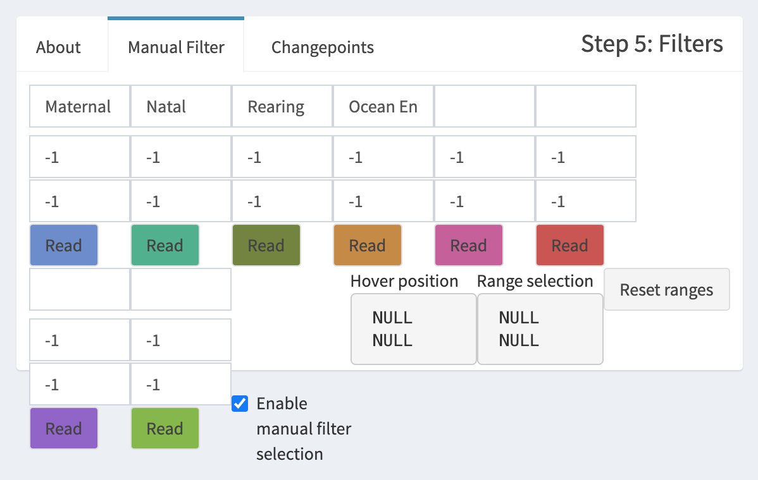

- You can enter the maternal signature in the boxes. Enter 0 in the top box and 225 in the bottom box. That area on the plot should highlight in blue.
- The natal signature requires some thought. Where does the first stable signature start after 225µm? Where does it end? Use your judgement and identify that signature.
  - To select it, hover over the start of where the natal signature starts with your mouse. Click and drag to highlight a box that covers the stable signature. Below the “Natal Signature” box click the green “Read” button and the area you defined will be recorded and highlighted in the plot.
- Repeat step 18 to define the Rearing Signature.
- Is there an overwintering signature in this fish? (sample 2012-LFH-3082) There is a big jump in the “total Sr (V)” plot around 650µm that corresponds to the ⁸⁷Sr/⁸⁶Sr signature overlapping the blue line representing the ocean signature…so, according to our definitions, this fish didn’t overwinter in fresh water, it went straight to the ocean. Skip the “Overwintering” box and define the location of the ocean period. Your sample should look something like this:
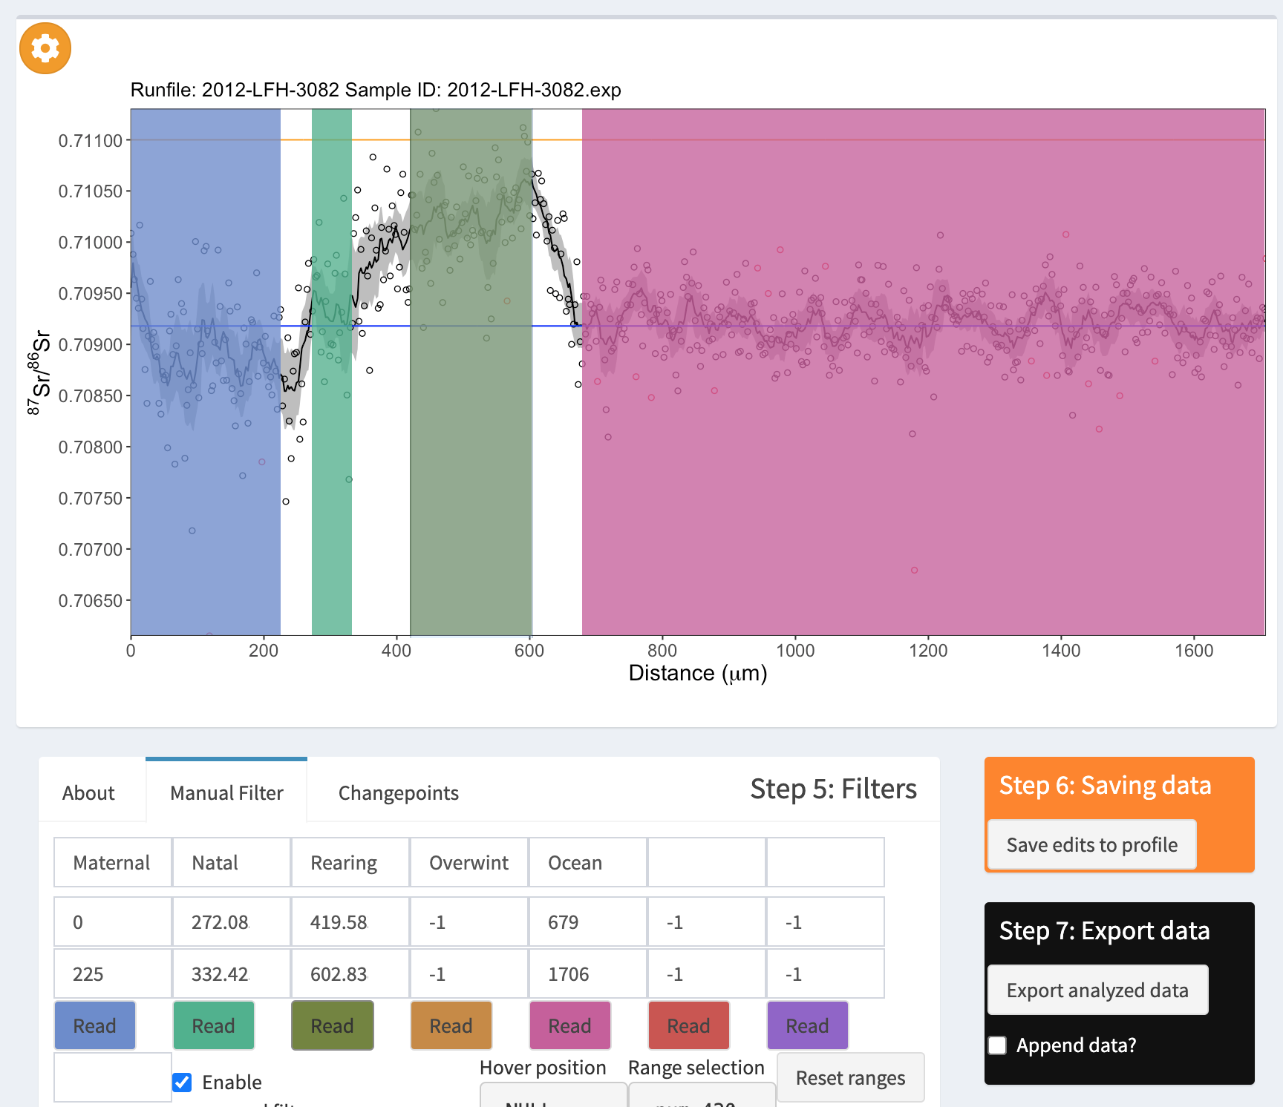
- Click “Save Edits to Profile”
- Click “Export analytical data”
- Now, define the life histories for the other samples in the project by repeating steps 14 through 22 for each sample. Remember that some fish may have overwintering signatures, others may not.
  - Don’t forget to click save edits AND export data for each sample to make sure it is saved.

Plotting Life History Data

To interpret the life-stage data we’ve gathered we need to plot it. That data is saved, so we’ll import it into R and make a plot.

- In RStudio go to the “Import Dataset” dropdown in the top right quadrant of the screen and select “From Text (readr)”
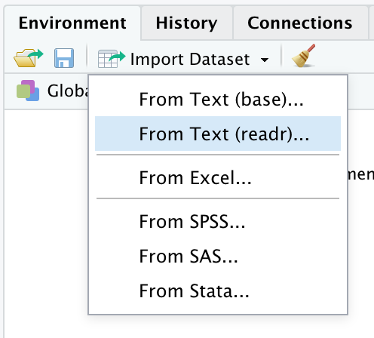
    - In the dialog that pops up click “Browse” and navigate to
IsoFishR-master/Projects/Otolith Lab/Data/Otolith Lab_04_analyzed_data.csv and open that file.
    - When the data loads, check to be sure that all the columns with numbers in them are listed as “numeric” and all the columns with numbers are listed as “double”. This should be automatic but it’s good to check.
    - Click the “Import” button to import the data into R.
- Next we need to create a plot of our data
  - Go to the File menu in the top left of the screen and click on “New File” in the menu.
  - Navigate to IsoFishR-master/Projects/Otolith Lab/Oto_Lab_Plotting_Script.R and open the script file.
  - This script contains everything you should need to create a plot. It will install the package ‘ggplot2’ to do the plotting if you don’t already have it installed.
    - If you already have ggplot installed highlight from line 5 in the script to the end before clicking the “Run” button to run the script.
    - If you do not have ggplot installed go ahead and click “Run” without highlighting to run the script.
  - This should create a plots that look similar to this for each sample

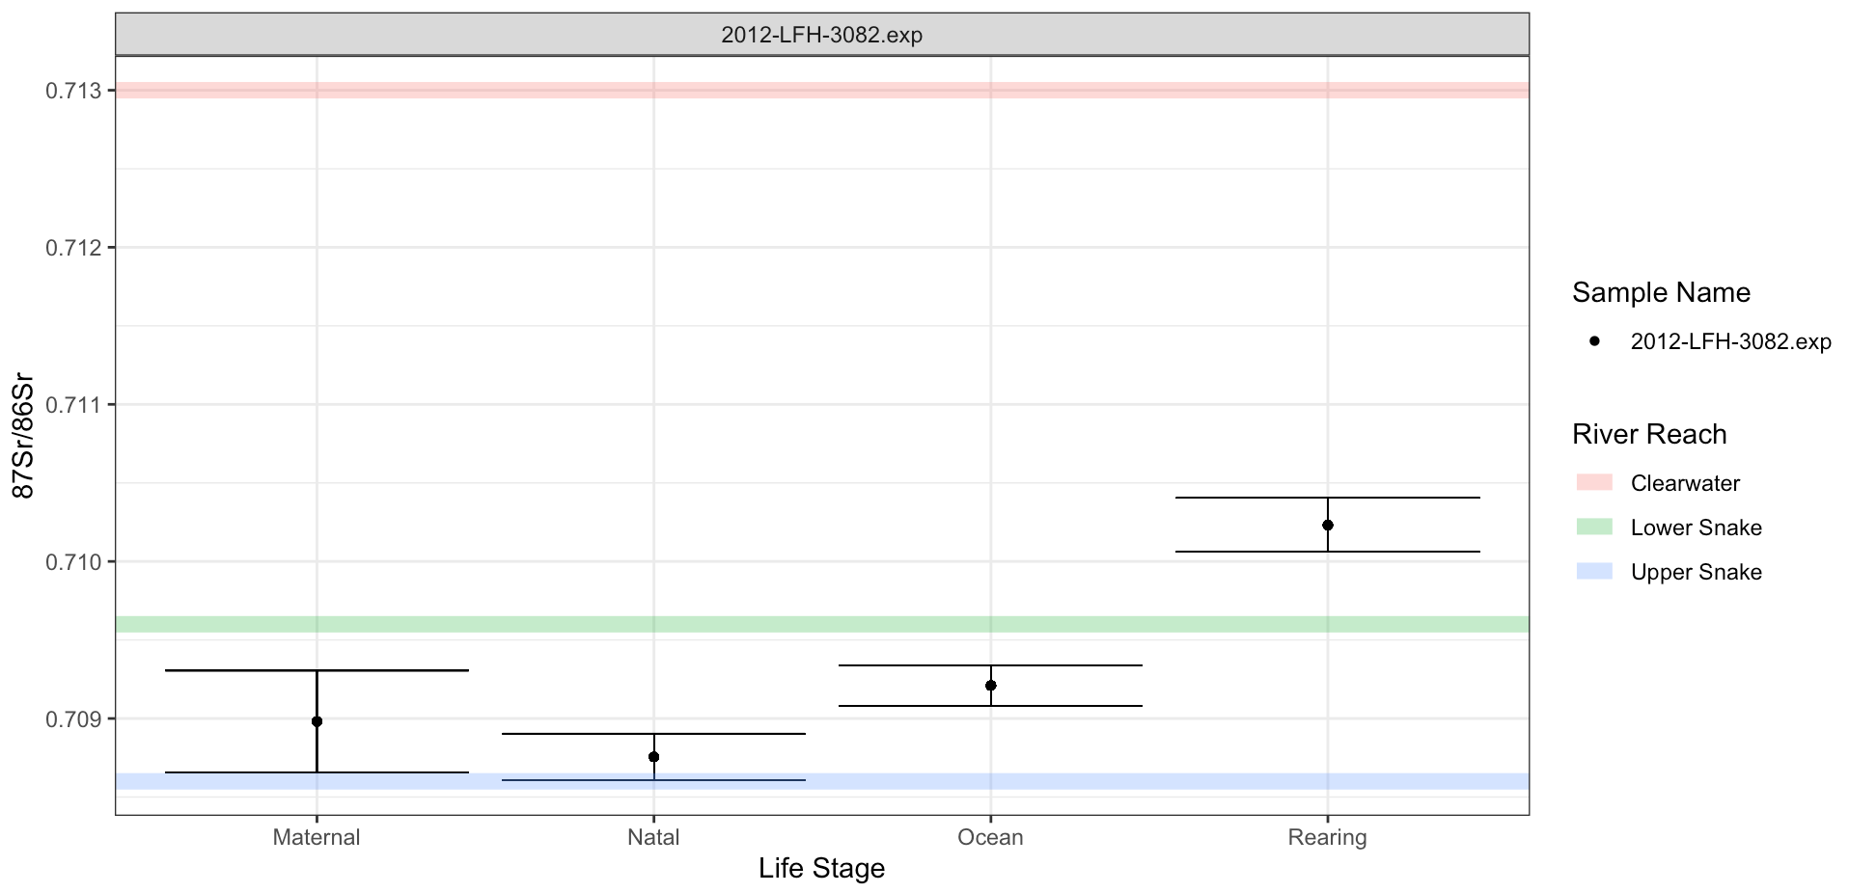
  - Adjust the plot window until the plots are visible and interpretable. Then click the “Export” dropdown and select “Copy to Clipboard”.
  - Paste the plot in the Data Plots section below.
- Navigate to IsoFishR-master/Projects/Otolith Lab/Plots/87Sr86Sr_analyzed where all of the analysis transect plots are stored.
  - Drag and drop them in the Data Plots section below. Size them as needed.

Data Plots
(paste your data plots here)

Interpreting the Data

Now that we have trimmed, analyzed, and plotted our data what does it tell us?

- What signatures are reflected in the “Maternal” region? Are they all the same? If so, why? If not, what might cause these differences?

- How many fish in our sample started life (Natal region) in each river reach?

- Did any rear outside the Lower Snake River? Which ones?

- Did any Overwinter in fresh water? If so, where did they overwinter?

- We want to know whether juvenile fish have different outmigration life histories. Do some spend more time in fresh water before entering the ocean, is there evidence of significant life history variation in these fish in your option? Point to specific evidence in your plots to justify your answer.

- In a few sentences, how difficult was it to pick the stable regions on the otolith? How much does human error play into these decisions, and how could you minimize the human error? What other fish ecology field/lab methods can you think of that are affected by human error like this?

